**Project 2 Report – Pythagorean Tree Fractal**

D11315807

Ardiawan Bagus Harisa

Department of CSIE

In this project, we are asked to create a Pythagorean fractal using three rectangles, with these specifications:

1. Different size: 3:4:5, 5:12:13, free ratio 🡪 choose using bottom right dropdown button. In case of 3:4:5 and 5:12:13, the alpha angle will be determined automatically.
2. Size of rectangles (default 100x100) 🡪 choose using size up-down button.
3. Color gradient 🡪 choose using color dropdown button.

This time, I implement the homework using .NET C# in windows form app. This [tutorial](https://www.csharphelper.com/howtos/howto_pythagorean_tree.html) by Rod Stephens really gives the great step through the fractal generation process.

**Setup**

To be able to run the project, you just need to use Visual Studio (2022), .NET C#, and windows form SDK installed. Then you can just run the debug or release version of the .exe file.

**How to Use**

Here is the visual look of the Pythagorean fractal. In here, you can set the recursive depth of the tree, the size of the rectangle, the alpha (angle), and the color.

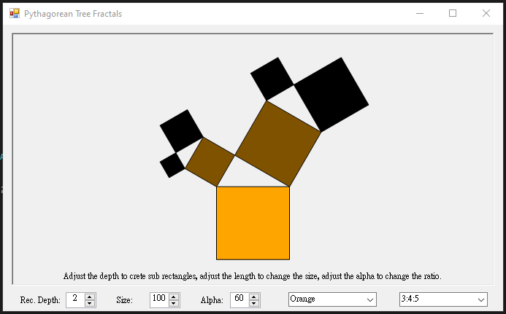

**Step-by-Step**

**Form1.cs**

First, I create the form window and attach some UI elements from the toolbox such as text label, combo box dropdown, numeric up and down arrow, and a picture box. The picture box is the main element to perform the drawing of the fractal.

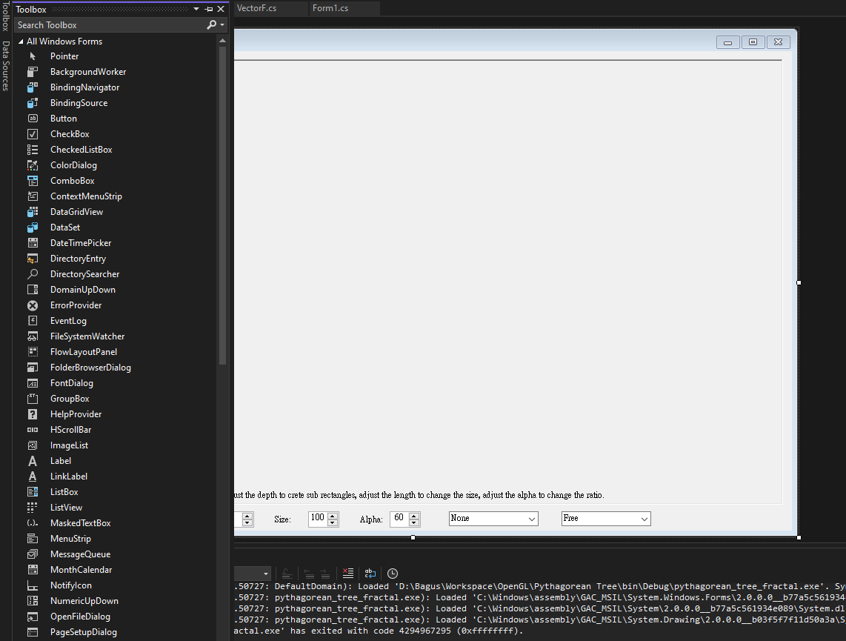

And here is the code view of that form. Basically, in windows form app, there are two files (views): code and designer views. The code is basically generated version of the visual designer form. In the following code, we can see the list of the UI components.

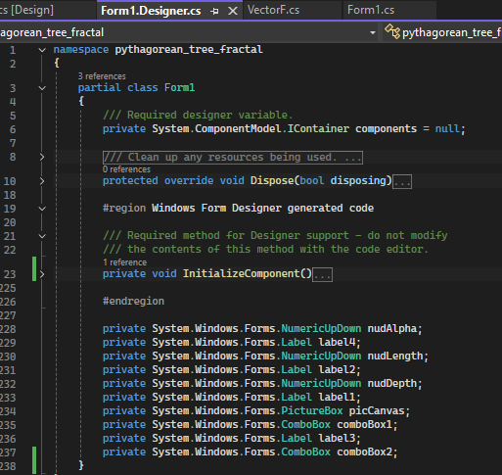

Generally, in Windows Form App, we can create as many forms as we want, then just call them onto the main program as follows. In here, I call the Form1 that I just created in the main function as entry point of the application. First, I enable the visual style of the form to follow the current modern style by calling the EnableVisualStyles(). Then, I set the application to use the newer version of text rendering (using GDI+ from .NET). Finally, I call the form that I created where I implemented the logic of the fractal.

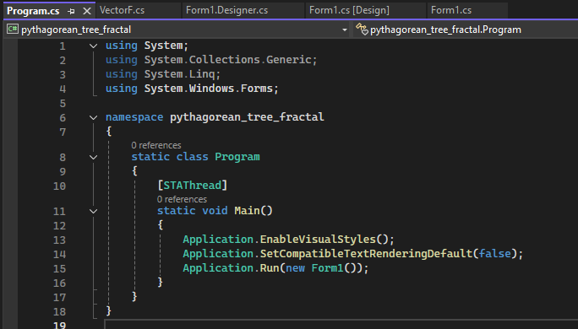

So, here is the steps to create the fractal:

1. Initialize all of the UI element.
2. Setup all of the logic variables including drawing function call.
   1. Here is where the recursive function to draw the tree is called.
3. I redraw if there is any change on the UI elements.

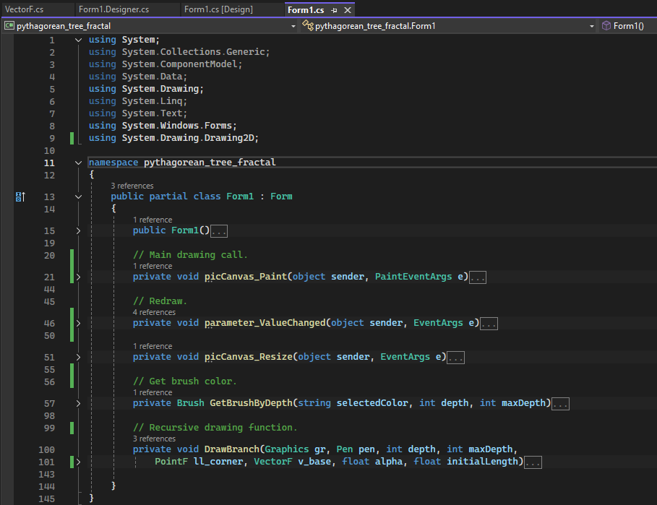

1. **Initialize UI element**

Basically, if we create the windows form using visual editor, the UI elements will all be automatically generated by the system. So, I don’t need to do much. Probably just check and rename.

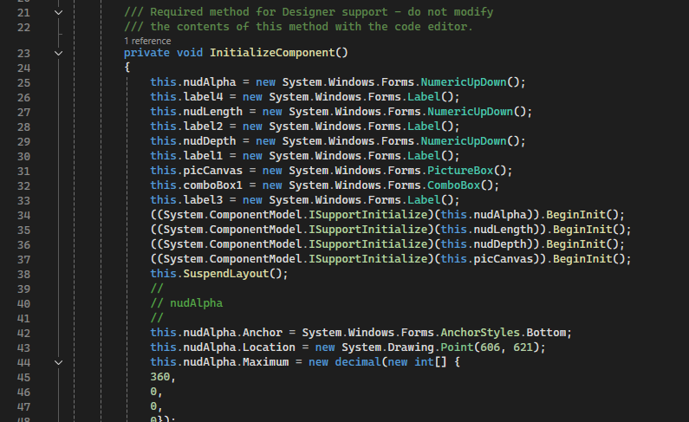

1. **Setup logical variables and call the drawing function**

In this picCanvas_Paint(), I intend to call the recursive function to draw the fractal tree. First, I make sure to clean up the background color of the canvas that later will be used as the main medium to draw. Second, I assign the parameters of recursive depth, the size of the triangle, the angle of the triangle, the position of the tree, and finally just call the recursive drawing function.

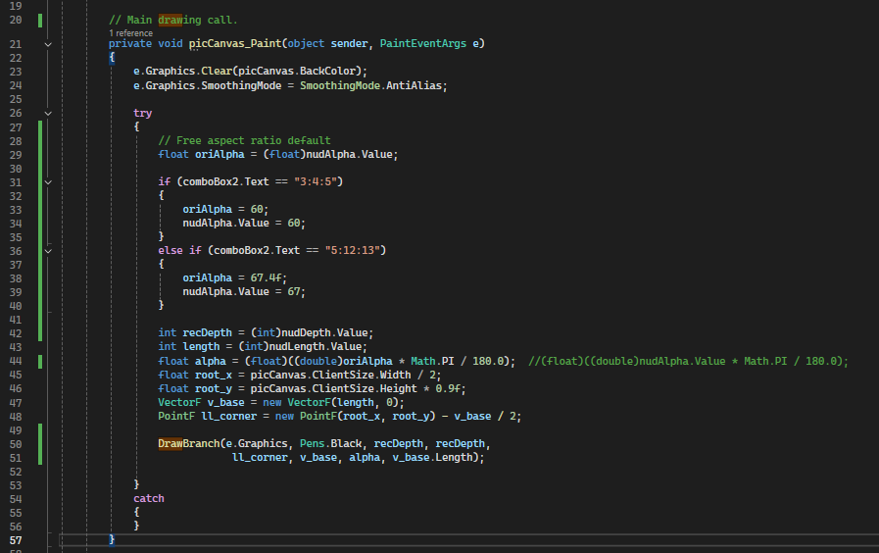

There you can see where I set the ratio of the triangle according to the user preference.

1. **Draw the tree**

To be able to draw the tree with modularity, I have a class to handle the vector operations, call VectorF. This class literally just handle the overload operations of vector and point.

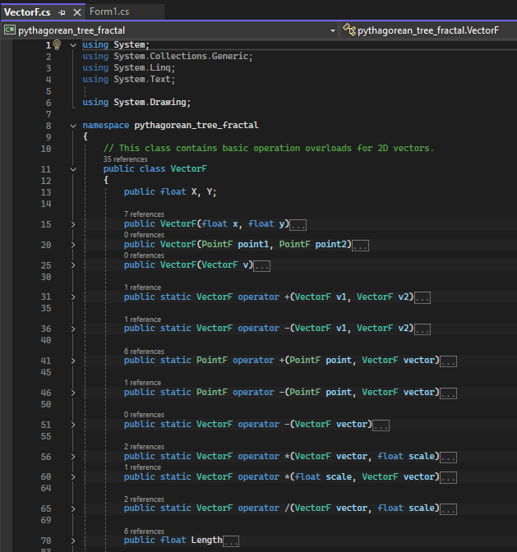

Here are some functions to handle the calculation of the angle to create the triangle. CW stands for clockwise, and CCW stands for counter clockwise.

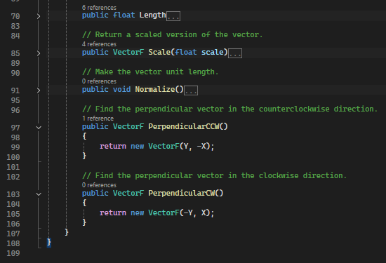

The graphics and pen type from the argument are data type in .NET graphic library to render the fractal tree. The use of Graphics gr is to draw shapes like polygons and lines. So, the graphics gr is passed to the main drawing canvas. The object pen will define the style of the lines to draw the outline of the rectangles.

To render the rectangle, we need to calculate its corner points. First, we need to determine the base width and orientation of the rectangle, using vector, in the counter clockwise direction. Then we calculate the all four points in array of points. We use lower left corner as a base to compute the other. Here is the order:

1. Lower left
2. Lower right
3. Upper right
4. Upper left

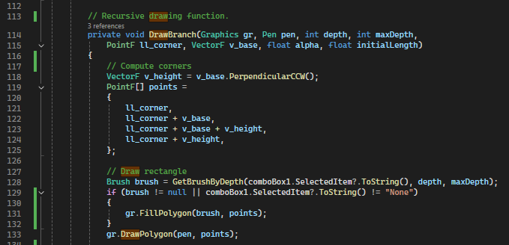

Then, I draw the rectangle(s). First, I need to prepare the drawing tool: brush and pen. Those are used to define the style of the drawing. For instance, the color of the rectangle is defined by brush, which is defined by the dropdown button and the depth of the tree.

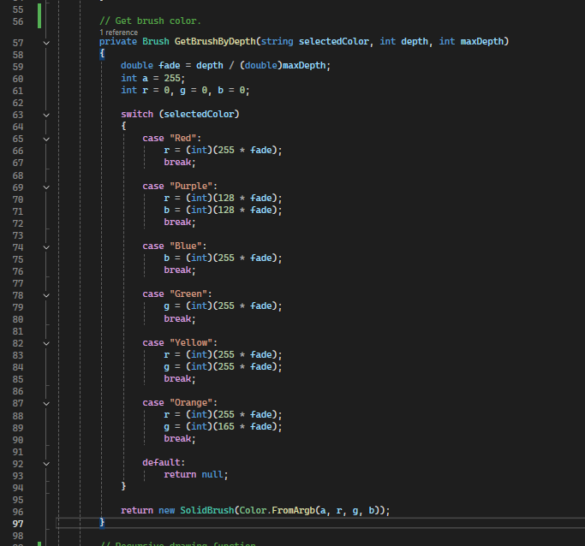

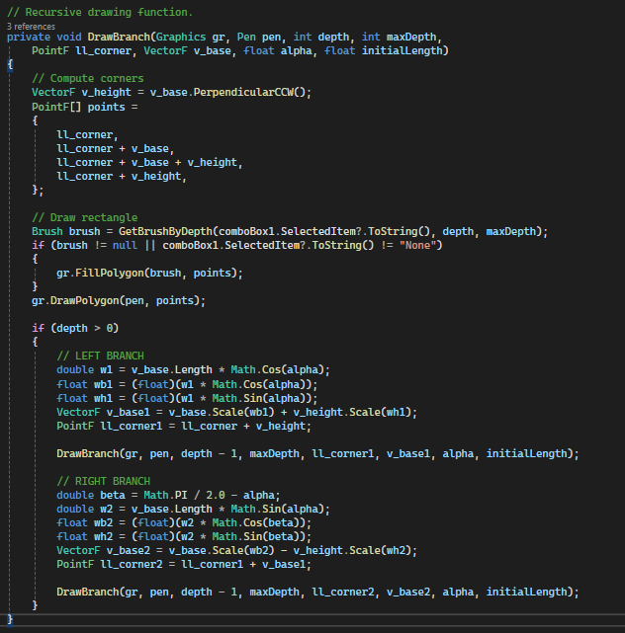

Then using the following recursive concept, I draw the rectangles.

1. Draw 1 rectangle
2. If depth > 0, draw two more rectangle
3. Recursive call

So, first, draw a rectangle as the base, as I mentioned before. Then, if the depth is more than zero, meaning I should draw two branches. Then, draw the left branch of the tree by calculating the base size and its relative position and orientation by calling its recursive function. Then, perform the similar call to the other (right) branch. The process will continue until there is no more depth to perform (depth = 0).

And these two functions will be called to redraw in case any update from the form (i.e., user edits the value).

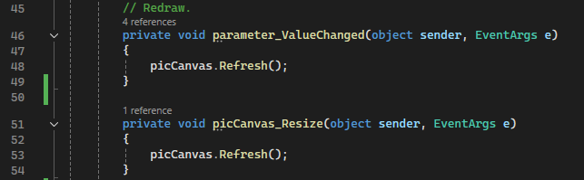

**Simulations**

